2 years, $2 million

Zebrafish whole brain modeling

Avoid contradictions

2-4 pages

**Summary**. (write at end)

**Significance**.⅔ page

**Innovation.** ⅓ page

**Approach.** ½-⅔ page, plus 1 figure, each aim

**Aim 1**. Whole-brain voltage imaging at single-cell, millisecond resolution

With the new and improved microscopes, and improved transgenic lines - increase the number of neurons imaged across the brain, reduce shadowing artifacts and increase total coverage across the brain.

**Rationale.** Recently, we achieved voltage imaging of ~¼ of all neurons distributed across the entire zebrafish brain at 200 volumes per second by developing remote-scanning light-sheet microscopy 1.0 (rsLSM 1.0). Building on this advance, the proposed work aims to achieve true whole-brain, single-cell, millisecond-resolution voltage imaging through the development of next-generation microscopy (rsLSM 2.0) and improved transgenic lines. rsLSM 2.0 will enable imaging of at least 80% of neurons across the brain, substantially reduce shadowing artifacts, expand total brain coverage, and support continuous whole-brain voltage recordings for more than 20 minutes.

Current Capability and Limitations (rsLSM 1.0):

We recently established a foundational baseline for this work by developing the first-generation Remote-Scanning Light-Sheet Microscope (rsLSM 1.0). As detailed in Wang et al. (2023), this system overcame the inertial limitations of conventional objective scanning by utilizing a lightweight (0.01 g) remote scanning mirror. This allowed us to achieve a volumetric imaging rate of 200.8 Hz—a critical threshold for resolving millisecond-scale voltage dynamics—across a volume covering the entire larval zebrafish brain ($900 \times 370 \times 200 \mu m^3$).

However, despite scanning the full volume, rsLSM 1.0 successfully resolved voltage traces from only **~1/4 of the neuronal population** (~25,000 neurons). Our analysis reveals three primary bottlenecks that rsLSM 2.0 must overcome to reach >80% coverage:

1. **Photon Efficiency:** The current single-path remote refocusing design discards 50% of fluorescence emission at the polarizing beam splitter. In the photon-starved regime of voltage imaging, this loss prevents the detection of dimmer or deeper neurons.
2. **Shadowing Artifacts:** The single-sided illumination in rsLSM 1.0 is susceptible to stripe artifacts caused by skin pigments and eyes, which obscure significant portions of the contralateral hemisphere.
3. Optical Access: The ventral forebrain (interocular region) remains optically inaccessible due to retinal occlusion in the current lateral illumination geometry.

Aim 1 is essentially the engineering solution to these three specific problems.This work will represent the first demonstration of near-complete, brain-wide voltage recording in a vertebrate at single-cell and millisecond resolution. By capturing neural activity at its native timescale and across nearly all neurons, this approach will greatly reduce the likelihood of missing neurons or fast activity events that play critical roles in neural computation.

**Methods.** rsLSM 2.0 will record voltage from more than 80% of neurons (~64k) across the entire larval brain (400×800×200 µm³) at single-cell (~0.7 µm pixels; 1.4 µm resolution, ~1/5 of the soma diameter[(Ahrens et al. 2013)](https://paperpile.com/c/VjYfxQ/q1yg)) and >200 Hz volume rate. Using three synchronized cameras, the system achieves 8,200 FPS (streamed to SSD RAID 0 arrays, each 32TB, 56GB/s max data rate via 16x PCIe 5.0 connection) over a 400×800 µm² field of view, enabling >200 Hz whole-brain or >1 kHz partial-brain (400×800×40 µm³) imaging, with 4–5 µm z-steps as in prior whole-brain light-sheet implementations for calcium activity [(Ahrens et al. 2013; Vladimirov et al. 2014)](https://paperpile.com/c/VjYfxQ/q1yg+ivLj). Illumination avoids eyes; a front-projected light sheet covers the interocular region. Blood-flow-induced moving stripe artifacts[(Taylor et al. 2018; Ricci et al. 2022)](https://paperpile.com/c/VjYfxQ/JdkG+bvEl) will be suppressed by a 12-kHz resonant scanner and NA 0.6 illumination objective to pivot the light sheet pivoting over ~50°. Preliminary testing with an 8-kHz resonant scanner achieved suppression in >90% stripes. High light efficiency is achieved using dual remote-scanning modules (effective NA = 1.0), enabling prolonged imaging with low phototoxicity. In combination with the photostable Positron2-Kv JF585 genetically encoded voltage indicator, this configuration supports >20 minutes of continuous imaging before reaching 50% photobleaching at ~10 mW total illumination power.

Ground-truth neuronal segmentation will be obtained using two-photon (2P) nuclear-label images (Aim 2). Raw data will be denoised offline using SUPPORT[(Eom et al. 2023)](https://paperpile.com/c/VjYfxQ/3wvM), and voltage signals will be demixed and extracted using adaptations of established voltage-imaging pipelines[(Xie et al. 2021; Cai et al. 2023; Cai et al. 2021)](https://paperpile.com/c/VjYfxQ/a3eW+pAt7+ruQq).

On the animal side, we have generated Tg(HuC:Gal4;2×UAS:Positron2-Kv) and Tg(HuC:Positron2-Kv) voltage indicator lines. To further improve expression uniformity, sensitivity, and photostability, we will evaluate additional expression systems (e.g., QF/QUAS [(Subedi et al. 2014; Burgess et al. 2020)](https://paperpile.com/c/VjYfxQ/DkZ8+0gxj)) and next-generation GEVIs. In addition, to enable cell-type identification, nuclear TMI markers[(Qian et al. 2023)](https://paperpile.com/c/VjYfxQ/RFjl) (same color, different photoswitching kinetics) will label excitatory, inhibitory, and monoaminergic classes. These markers will be imaged in sessions orthogonal to GEVI imaging, enabling post hoc cell-type assignment without spectral interference.

**Pitfalls and how to overcome them.** Pitfall: Bright light-sheet illumination may serve as a strong visual stimulus, potentially altering fish behavior or underlying brain states. Mitigation: To minimize this effect, we will physically block the illumination light from reaching the fish’s eyes or generate color-blind transgenic lines that are insensitive to the GEVI excitation wavelength.

**Aim 2**. Whole-brain two-photon holographic optogenetics at single-cell and millisecond precision

**Rationale.** Activity maps alone cannot establish causality. Two neurons that fire within milliseconds may be directly connected, or they may simply receive shared input, and distinct network architectures can generate indistinguishable activity patterns [(Prinz et al. 2004)](https://paperpile.com/c/VjYfxQ/vcVK). Establishing causality requires temporally precise, cell-specific perturbation. State-of-the-art two-photon holographic optogenetic systems can stimulate tens of neurons within a limited volume (approximately 70 neurons in zebrafish within 350 × 350 × 60 µm³, or ~80 neurons in mice within 480 × 480 × 150 µm³ [(Faini et al. 2023; Yang et al. 2018)](https://paperpile.com/c/VjYfxQ/uyfA+x8aM)). However, no existing system provides whole-brain coverage or integrates stimulation with voltage imaging.

We will develop a two-photon holographic stimulator capable of activating or silencing any selected neuron across the brain with cellular and millisecond precision and a pattern update rate exceeding 500 Hz, and integrate it with whole-brain voltage imaging. This platform will be the first to simultaneously record from and write to all neurons in a vertebrate brain at millisecond temporal resolution.

**Methods.** A custom 2P system will stimulate arbitrary neuronal ensembles across the ~400×800×200 µm³ brain with single-cell resolution and millisecond precision. A high-power femtosecond laser (>20 W average power, >40 µJ pulse energy, 1030 nm center wavelength) will enable the simultaneous activation of tens to hundreds of neurons, consistent with prior demonstrations [(Faini et al. 2023)](https://paperpile.com/c/VjYfxQ/uyfA). A 1024 × 1024 pixel spatial light modulator (SLM) operating at 500 Hz will support rapid hologram updates, allowing stimulation patterns to be refreshed on millisecond timescales to emulate fast neural sequences. Temporal focusing[(Shemesh et al. 2017; Papagiakoumou et al. 2020)](https://paperpile.com/c/VjYfxQ/E5O5+7G28) will yield ~6 µm disk foci matched to neuronal soma size, minimizing off-target activation. Power uniformity will be ensured by pre-calibrating fluorescent samples and applying power-weighting to compensate for SLM edge losses.

In parallel, we will generate new pan-neuronal transgenic lines expressing blue-shifted excitatory and inhibitory opsins, including soCoChR[(Shemesh et al. 2017)](https://paperpile.com/c/VjYfxQ/E5O5), and ST-eGtACR1[(Mardinly et al. 2018)](https://paperpile.com/c/VjYfxQ/py9F). These opsins retain ~50% of their maximal response under 1030 nm two-photon excitation while exhibiting minimal sensitivity at the excitation wavelength used for genetically encoded voltage indicators (589 nm). Crossing these lines with GEVI and TMI cell-type marker [(Qian et al. 2023)](https://paperpile.com/c/VjYfxQ/RFjl) lines will produce animals that support whole-brain voltage imaging, targeted optogenetics, and genetic cell-type identification within a single experiment.

**Pitfalls and how to overcome them.**

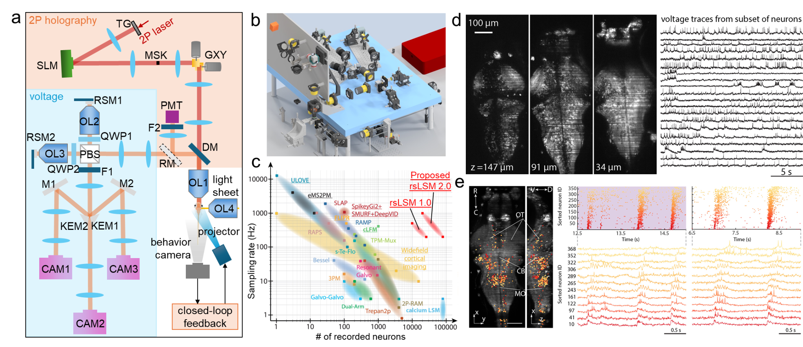

**Figure 1. Whole-brain voltage recording and manipulation platform (Aim 1, Aim 2). (a)** Schematic showing whole-brain voltage imaging (blue), 2P holographic optogenetics (red), and close-loop behavior paradigm. Key components: OL, objective lens; DM, dichroic mirror; GXY, x-y galvo; SLM, spatial light modulator; RSM, remote-scanning mirror; PBS, polarized beam splitter; KEM, knife-edge mirror; CAM, camera; TG, temporal focusing grating. **(b)** CAD rendering of the proposed platform layout. **(c)** Proposed rsLFM 2.0 will extend my PhD work, achieving ~100× higher throughput (# neurons × sampling rate) than existing methods. Voltage imaging methods are underlined. Adapted from [(Lecoq et al. 2023)](https://paperpile.com/c/VjYfxQ/ASiA) **(d)** rsLFM 1.0 recorded voltage from ~1/4 of neurons (~25,000) across the brain. **(e)** rsLFM 1.0 revealed millisecond-scale neuronal firing sequences. Left: sequence mapped onto the 3D brain (temporal order color-coded, deep red to light orange). Right: raster plot and voltage traces from multiple sequence events.

**Aim 3**. Acquisition and Tracing of Zebrafish Whole-Brain Connectomic Maps.

**Rationale.** A key component in achieving a holistic understanding of the brain is the acquisition of detailed maps of the spatial organization and connectivity between neurons.These detailed maps, or connectomes, can be computationally constructed from ≈10 nm-resolution volumetric imaging data sets. We will acquire these data sets for whole zebrafish brains using recent advancements in light microscopy-based connectomics by which we can use a diffraction-limited microscope on an expanded, protein-stained brain sample to achieve synaptic resolution of protein density.

[COMPUTATIONAL PROCESSING FOR CONNECTOME GENERATION]

A particular motivating factor for this aim is the ability to correlate and register connectomic and functional data within an individual larvae. Enabling structurally-informed [REGISTRATION W/ FUNCTIONAL DATA?]

Design, reasoning

* Need for methods that can allow for the acquisition of volumetric raw data for multiple fish, which can be used for reconstruction of multiple connectomes
* Light microscopy-based connectomics has be demonstrated

Validation metric - hours to trace a fish of manual labor (33 years for fruit fly), # of errors per unit length…?

Can be aspirational - this is not a renewable grant

Check LICONN, <https://www.biorxiv.org/content/10.1101/2025.09.26.678648v1>

Faster/better/cheaper → win the race OR **new kind of thing → pave the way as pioneers**

Demo metric - certain # of fish, pre-image with voltage

Barcoding synapses? <https://www.biorxiv.org/content/10.1101/2025.11.25.690442v1>

Barcoding? <https://www.biorxiv.org/content/10.1101/2025.02.13.638129v3>

Maybe AI just solves it, <https://www.biorxiv.org/content/10.1101/2025.05.16.654254v1>

**Methods.** We will utilize transgenic zebrafish containing constructs for sparse expression of GFP in various neuronal populations (e.g. *Tg*(UAS:GFP) crossed with *Tg*(Gal4:Gad1b) for marking GABAergic neurons, Figure X.C or mosiaced animals, Figure XX) to use as a ground truth marker for tracing validation. Larvae aged 5–7 dpf will be processed according to a modified light microscopy-based connectomics[1](https://www.zotero.org/google-docs/?RHf4AE) protocol. Briefly: larvae will be fixed in an acrylamide-paraformaldehide solution and permeabilized in trypsin, then brains will be microdissected out of the surrounding tissue, Figure X.A. Isolated brains will be treated with a high pH buffer for antigen retrieval, acrylate modified in a bifunctional epoxide buffer, and cast into a swellable acrylate-acrylamide hydrogel. The gelled brains will be digested in a collagenase-containing buffer and denaturated in a sodium docedyl sulfate/β-mercaptoethanol/Triton X-100 denaturation cocktail at high temperature. The denatured gels will be passivated to inactivate reactive gel side chains and immunostained to enhance GFP signal. Stained gels will be cast into a stabilizing hydrogel and then processed for a second round of expansion, resulting in an approximately ≈16x expansion factor. These gels will be dyed with a pan-protein NHS-ester stain, then serially sectioned and imaged at a 40x optical magnification (effective magnification of approximately ≈500x).

[DRAFT COMPUTATIONAL PIPELINE]

[CO-REGISTRATION WITH FUNCTIONAL PIPELINE]

**Pitfalls and how to overcome them.**

* Difficulty with tissue cracking … use dissected brains rather than whole mount tissue, also use small portions of tissue for initial development
* Consistent mounting brains for galatians … use molds or other guides for gel formation
* Deep imaging into intact gels … use serial slicing and confocal imaging of gelled brains

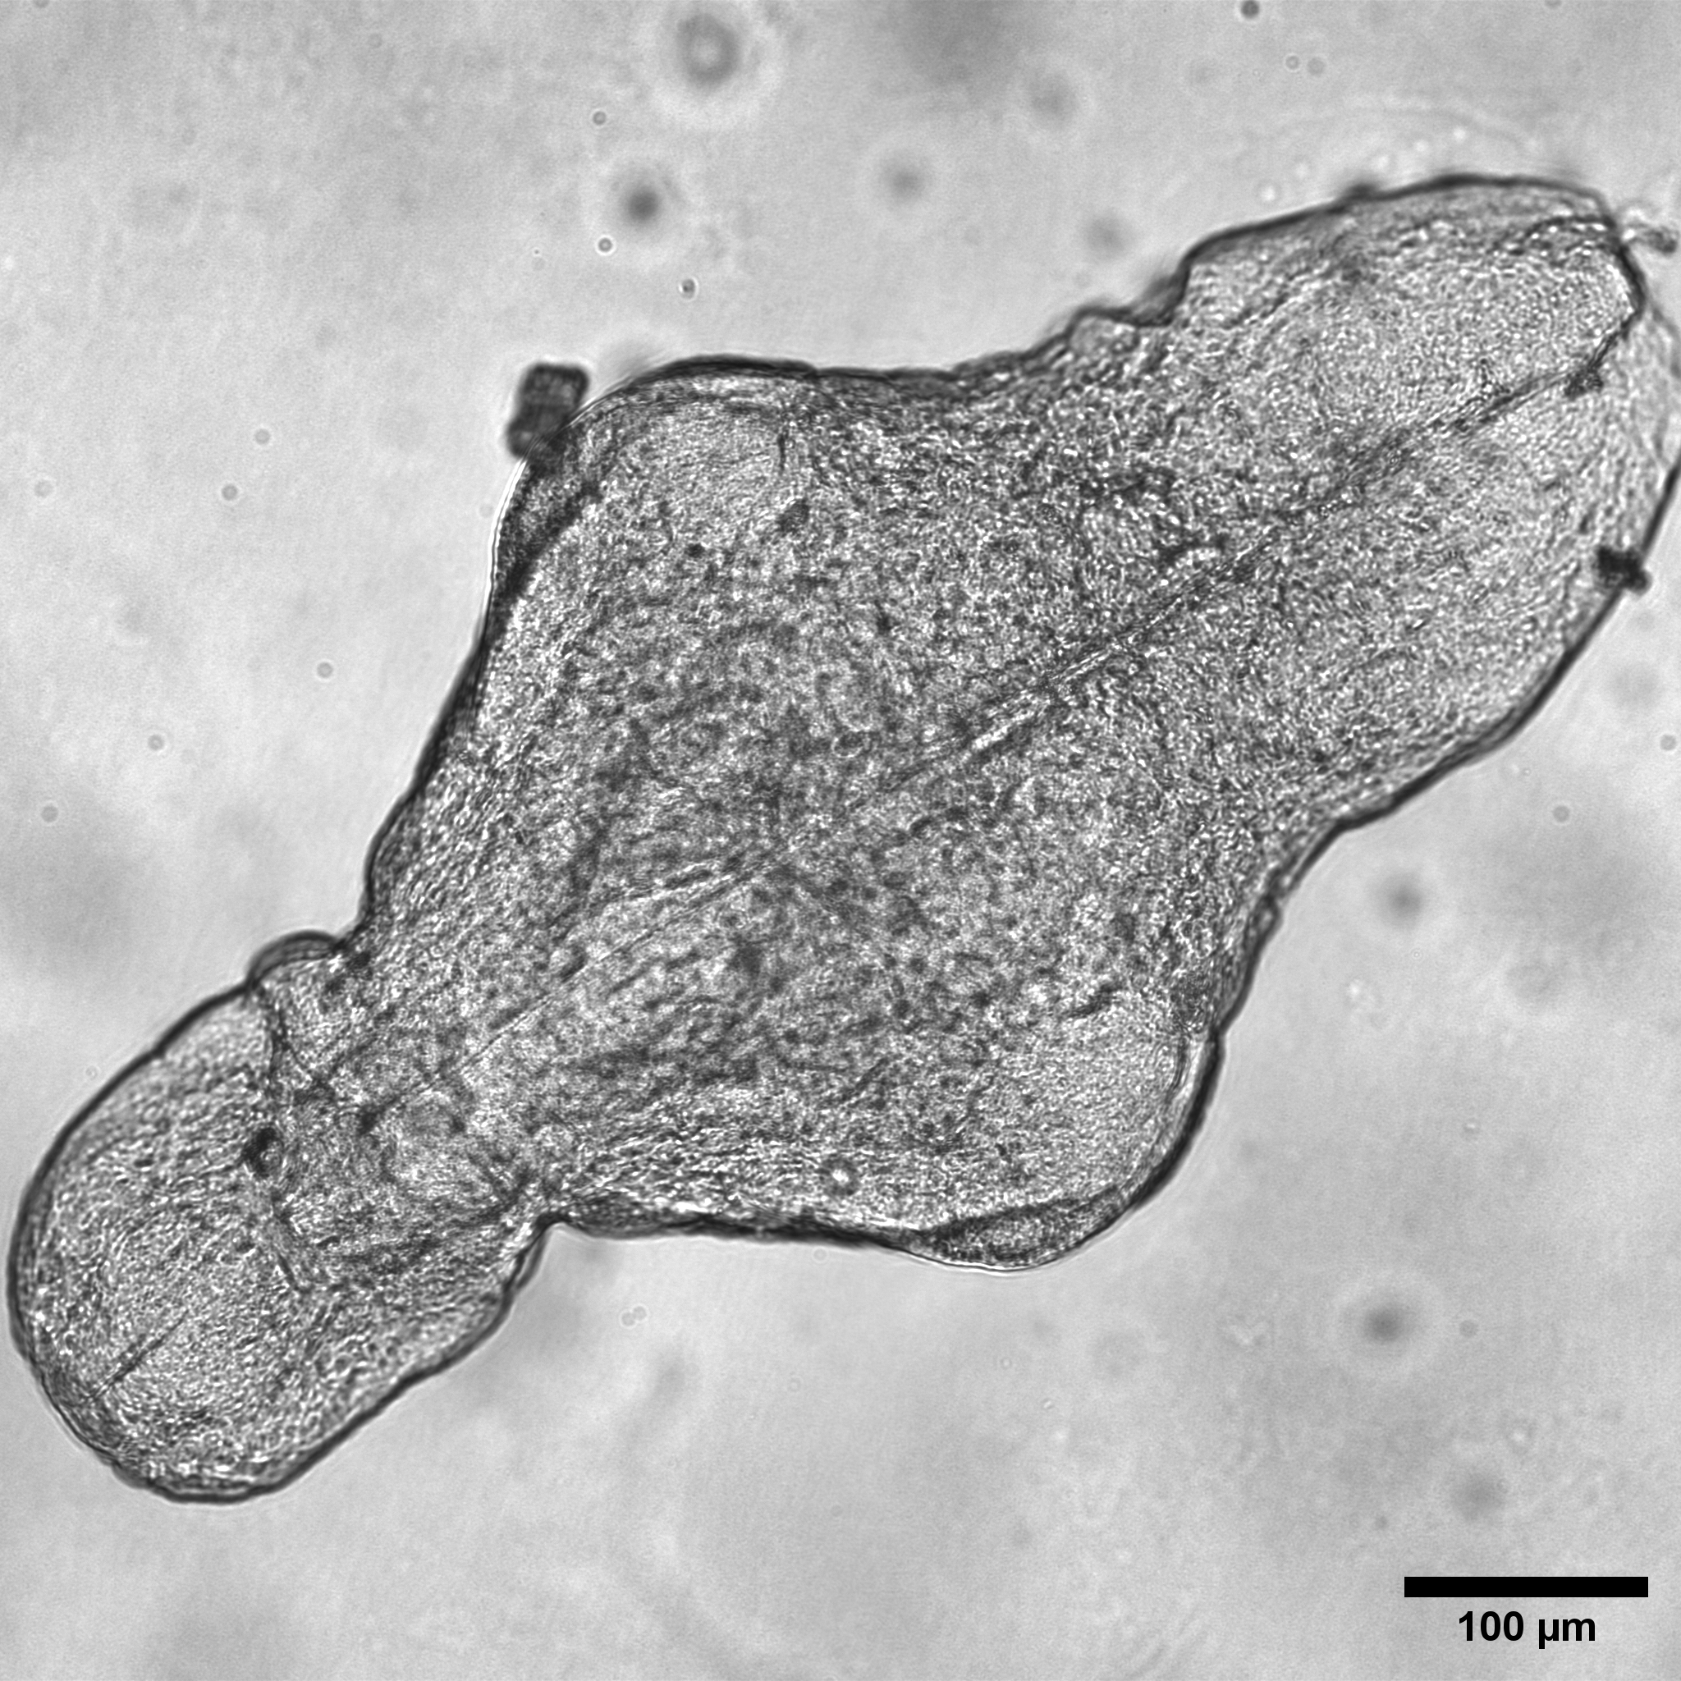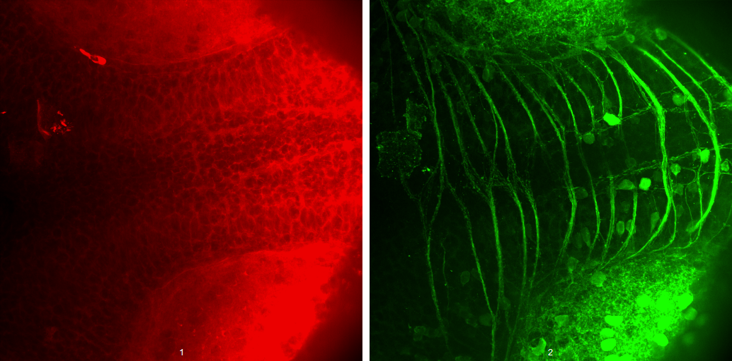

**Figure X. Preliminary data for tracing and proofreading in expanded zebrafish larvae. A. Whole zebrafish brain isolated from a 5 dpf larvae by microdissection. B, C 10x optical magnification image ofConfocal image**

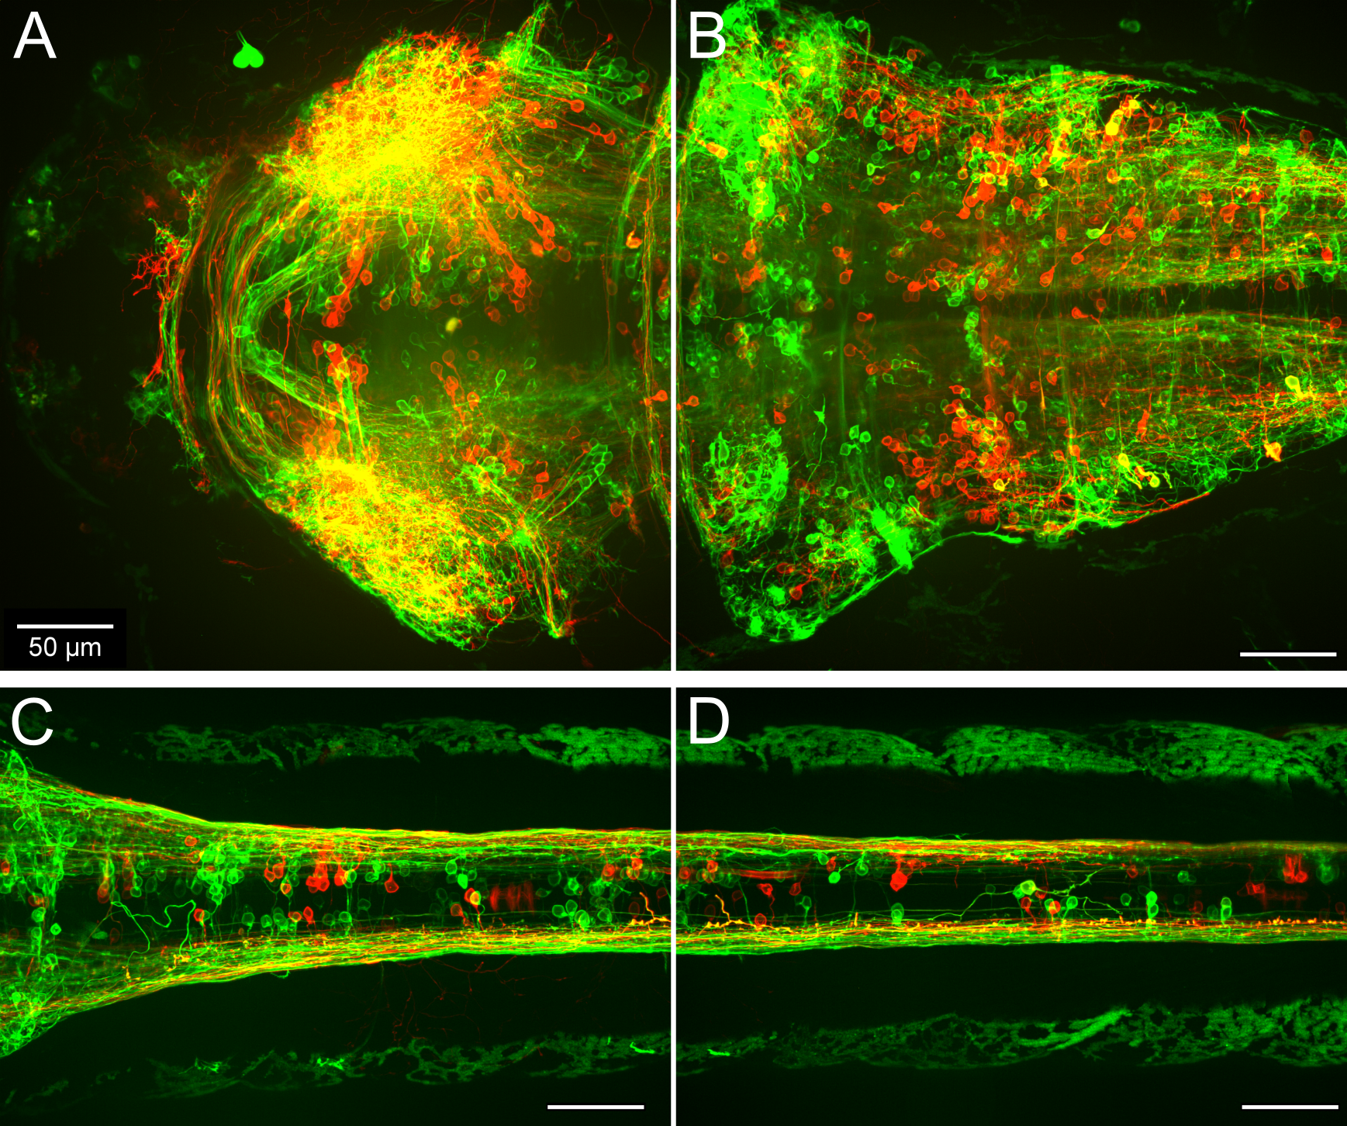

**Figure XX -** Max-projection confocal images from the midbrain and tectum (A), hindbrain (B), and spinal cord (C-D) of unexpanded 3 dpf mosaic animals following library transgenesis with a 50:50 mixture of plasmids containing constructs for neuronal expression of mScarlet or EGFP, fused to a CAAX tag for membrane targeting. Scale bar: 50 μm.

**Aim 4**. Development of an Antibody Library for Zebrafish Synapse, Subtype, and Functional Marking

In situ sequencing…

**Rationale.** In addition to functional activity and structural connectivity, the ability to render molecular information from the brain tissue is critical for both the investigation of hypotheses specific to brain function and processing ~~as well as enables us to have a clear route for the investigation of different disease models~~. Here in this aim, we will develop a library of antibodies which are shown to work robustly in zebrafish tissue and which cover a gamut of various markers for:

* synapse identification - markers which will inform connectomic analyses by highlighting providing a validation marker cell connections.
* classification of different neuronal subtypes - markers which will classify neurons (by receptor of neurotransmitter) as, for example, excitatory or inhibitory,
* functional state- markers which will identify neurons which were recently active just prior to fixation of the larvae.

**Methods.** Methods section of paper

* Identify zebrafish-expresssed antigen targets for neuron subtype classification using a selection of antibody targets.
* Synapse markers
* Screening of antibodies compatible with the LICONN expansion protocol.

Validation metric, at least 10 antibodies with SNR > 10, and ideally 50

Demo, universal synaptic stain, 5 antibodies for each of ion channels, transmitters, receptors, and …

Consider screening against [Absee catalog](https://docs.google.com/spreadsheets/d/18KoGR0k7269h_0BXuduPEonM1ztw9z6P/edit?usp=sharing&ouid=117600653040075699203&rtpof=true&sd=true).

**Pitfalls how to overcome them.**

* Difficulty to distinguish a large number of antigens … adapt antibody stripping and re-staining protocols from mouse brain development.
* Alternative to staining against different targets can be to stain against a robust epitpope differentially expressed in specific cell populations.

**Aim 4-5 Bibliography.**

[1.](https://www.zotero.org/google-docs/?OIPxmu)[Tavakoli, M. R. *et al.* Light-microscopy-based connectomic reconstruction of mammalian brain tissue. *Nature* **642**, 398–410 (2025).](https://www.zotero.org/google-docs/?OIPxmu)

### **Aim 5: Deciphering the Dynamical Stability of Consciousness via Whole-Brain Voltage Imaging**

**Rationale**

**The neural mechanisms underlying anesthetic-induced unconsciousness remain one of medicine’s most profound unsolved problems. While GABAergic anesthetics (e.g., propofol) stabilize neural activity into low-entropy states, ketamine induces a unique “dissociative” unconsciousness characterized by high-frequency gamma bursts. Leveraging our new capacity to record millisecond-precision activity from neurons distributed across the entire brain, we will observe and analyze whole-brain waves and coordinated patterns that were previously impossible to study. This allows us to test whether the ketamine-induced state represents a fundamental destabilization of network dynamics as the brain transitions between stability and chaos.**

*Some may say that the ultimate question of neuroscience is to understand conscious experience, in addition to behavior, computation, intelligence, communication/language and representation. An interesting place to start from, to probe at the first, is to study the effect of drug molecules that affect conscious experience, and especially anaesthetics, which presumably can “turn off” conscious experience, and psychoactive drugs, which can alter the conscious experience through short-term or long-term effects. Ketamine is an especially interesting molecule in this regard, as it can have all three different effects on the brain, dependent on the dose. At high doses (xx-xx mg/kg) it is an anesthetic, at medium doses (xx-xx mg/kg) it is a dissociative and psychedelic, and at low doses (xx-xx mg/kg) it has antidepressant effects, which have shown to be therapeutic in humans especially over long-term low-dose administration. The mechanisms that mediate all these three different effects are mysterious and poorly understood, but they are remarkably well conserved among vertebrate brains - ketamine has the same effects on humans, non-human primates, mice and zebrafish.*

*Many predictions and hypotheses have been raised about the mechanisms underlying the effects of drugs such as ketamine on conscious experience, but many of them have been impossible to test directly, as we were limited by the techniques available for brain activity recording. Primarily, hypotheses that relate to brain dynamics that occur across the entire brain, mediated by the distributed activity of neurons acting in coordination in different regions, with some of these processes and patterns of activity being very fast (on the order of milliseconds to seconds). At the moment, all the methods for brain recording which are available in humans are too low resolution (i.e EEG, fMRI) or cover only targeted small areas of the brain (implantable electrodes / arrays) to enable observing that directly. In animal models, calcium imaging has recently emerged as enabling high resolution recording of brain activity at the level of individual neurons and with temporal resolution of tens to hundreds of milliseconds. In larval zebrafish, this method has even been possible to record from the whole brain at once, thanks to the unique optical transparency of the larval zebrafish. However, the constraints of calcium imaging have been limiting in several critical aspects - (1) the temporal resolution (tens to hundred of milliseconds) is still too low to observe large swaths of the computation which happens at the millisecond scale; (2) calcium imaging records a secondary product of brain activity, namely the increases in intracellular calcium that occur in response to neurons firing. As a result, calcium imaging generally doesn’t provide access to actual neuron firing events, but rather a smoothed-out indication of which neurons are firing more or less at any given time-bin. Furthermore, calcium imaging is completely blind to subthreshold changes in neuronal membrane potential, which are critical aspects of neuronal hypo and hyperexcitability states and have been suggested to play a key role in global brain dynamics associated with conscious states, and neuronal coordination in anesthesia. Voltage imaging, in comparison, solves all of this - it enables direct recording of direct neuronal state and firing activity. As described above, our lab developed a unique platform that enables whole-brain voltage imaging at millisecond resolution of neurons across the whole brain in larval zebrafish. We will leverage this platform to study the fast global brain dynamics that are associated with the modulatory effects of drugs such as ketamine on the conscious state of the animal. Initially, we will be looking at predictions from the field on the role and effect of global brain oscillations across the whole spectrum - from delta (0.5-4 hz), Theta (4-8 Hz), Alpha (8-12 Hz), Beta (12-30 Hz) up to Gamma (30-100 Hz) waves, on the anesthetic, dissociative, psychedelic and anti-depressive effects of ketamine. In addition, we will explore the data in an exploratory data-driven way to analyze the correlation between different distributed patterns of activity and the state transitions in brain activity that are mediated by the drug. We will be recording behavior of the animals at the same time, and comparing that to the patterns of activity that we record.*

**Methods.** Methods section of paper

**Experimental Design**

**We will utilize the rsLSM 1.0 to perform whole-brain voltage imaging in larval zebrafish (5-8 dpf, elavl3:Voltron2/Positron2) undergoing anesthetic state transitions.**

* **Paradigm: A modified manifold will be used for precise fluidic control across three conditions:**
  1. **Baseline (E3 Medium): Awake, responsive state.**
  2. **Subanesthetic Ketamine (0.2% v/v): Altered arousal/sedation.**
  3. **Anesthetic Ketamine (0.8% v/v): Complete loss of responsiveness.**
* **Behavioral Readout: Responsiveness will be monitored via noxious heat-induced tail-flick reflexes using an IR laser throughout the imaging session.**

Zebrafish larvae of the transgenic pan-neuronal GEVI line UAS::Voltron2-ST;;HuC::Gal4;nacre aged 5-8 dpf will be incubated in 3 uM JF525 dye in water for 1 hour, followed by washing in regular fish water. Each larva will be embedded in agarose with head fixed and tail free, allowing simultaneous brain imaging and behavioral monitoring. We will employ a customized fluidic delivery system for rapid solution exchanges between E3 medium and ketamine solutions (Swain, 2024). Two ketamine concentrations will be tested: 0.2% v/v (sub-anesthetic) and 0.8% v/v (anesthetic), based on established zebrafish protocols (Zakhary et al., 2011). Behavioral responsiveness will be assessed using NIR laser-evoked tail-flick reflexes as a proxy for consciousness (Dempsey et al., 2022)

.

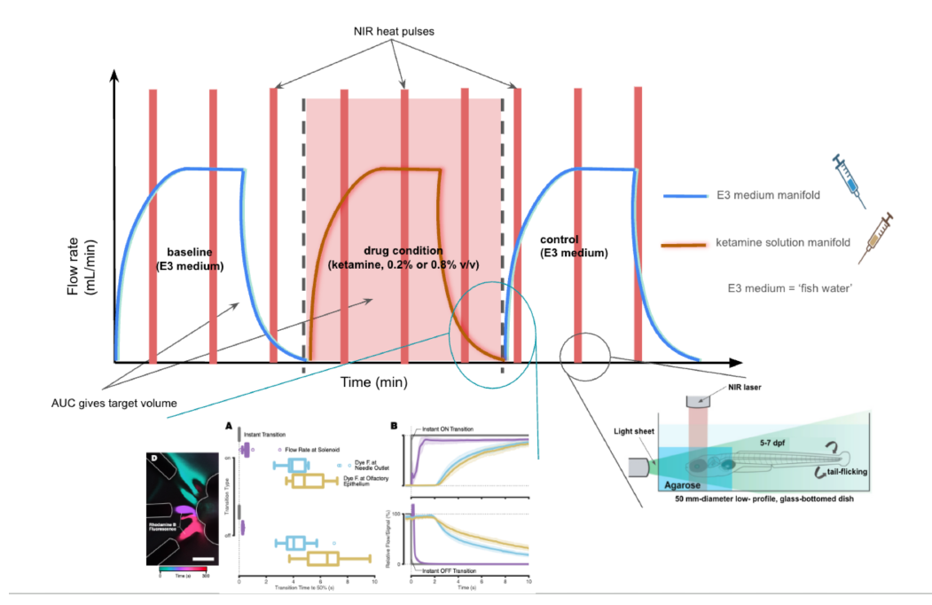

**Figure XX. Temporal structure of a single experiment integrating drug delivery and behavioral probing.**

Fish are initially perfused with control solution (E3 medium or ‘fish water’) for baseline recording, followed by bath application of ketamine (0.2% or 0.8% v/v), and finally washed back into control medium. A fluidic manifold controls switching between reservoirs, achieving near-complete bath exchange within ~1-2 minutes. Red vertical bars indicate periodic IR heat pulse stimuli (e.g. ~5 seconds each, spaced ~1 minute apart) to the larva’s head used to assess behavioral responsiveness (tail-flick reflex) throughout baseline, ketamine, and recovery phases. This structure mimics anesthesia induction and emergence phases, allowing each fish to serve as its own control.

Main figure: Blue and brown traces indicate the flow of control E3 medium and ketamine solution, respectively, as a function of time. The transition phases (dashed lines) involve simultaneous inflow of new solution and removal of old solution. In each trial, after an initial baseline period in E3, ketamine is introduced (pink shaded region) and maintained for a set duration (e.g. 5–10 min) before switching back to E3 for washout. Two ketamine dose conditions are planned: a sub-anesthetic dose (0.2% v/v ketamine) and a higher anesthetic dose (0.8% v/v), each tested in separate trials.

Bottom-right inset: The head of the zebrafish is encased in low-melt agarose, leaving the tail free to move. Heat produced by an NIR laser causes the unconditioned response of tail flicking in normal, awake zebrafish.

Bottom-left inset: We will validate the capacity and timing of our modified setup to deliver and withdraw the desired bath concentrations and volumes by performing synthetic dye (e.g. rhodamine B) quantification to determine delays in the transition times for switching between bath solutions. Made with [Biorender.com](http://biorender.com) and with figures adapted from Swain (2024) and Dempsey et al. (2022).

**Analysis & Modeling**

**We will apply dynamical systems theory to test the hypothesis that ketamine-induced unconsciousness corresponds to a “critical” destabilization of brain networks:**

* **Neural State Space: Dimensionality reduction (PCA, UMAP) will visualize the trajectory of brain activity to determine if the unconscious state occupies a discrete, metastable attractor distinct from sleep or awake states.**
* **Predictability as a Proxy for Stability: Following ZAPbench guidelines, we will train self-supervised neural network forecasting models (e.g., Transformers or LSTMs) on the voltage data. We predict that the transition to unconsciousness will be marked by a drop in the "forecastability" of neural dynamics, quantifying the network's descent into chaotic instability.**

**Supporting Figures and Exploratory Analysis**

* **Brain-wide Activity Maps: Frequency-specific activity (e.g., delta and theta power) will be computed and visualized to render brain-wide maps of state-dependent power distributions.**
* **Synchrony Metrics: We will compute phase-locking values (PLV) and other metrics to determine how ketamine modulates inter- versus intra-hemispheric oscillatory coordination.**
* **Dynamical Stability Frameworks: Diagrams will illustrate the concept of state trajectory divergence under anesthesia and the corresponding loss of attractor stability.**

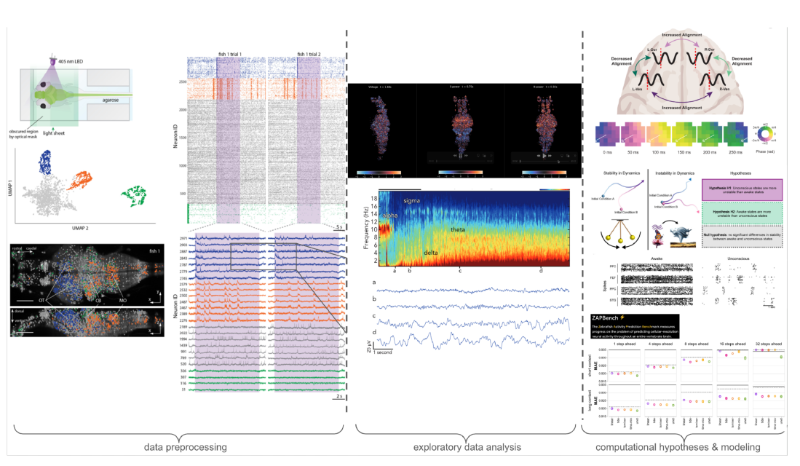**Figure XX.**

Multiscale analysis and modeling pipeline for whole-brain voltage imaging of ketamine-induced brain state transitions in larval zebrafish.

This figure outlines the proposed computational pipeline for data processing, signal analysis, and neural predictability modeling.

Left panel: Raw voltage imaging data are acquired at ~200 Hz using a custom-built remote-focusing light-sheet microscope that captures neural dynamics across nearly the entire larval zebrafish brain at single-cell resolution (adapted from Wang et al., 2023). After preprocessing—including motion correction, image registration, cell segmentation (e.g., with Cellpose), and spike inference using VolPy—single-neuron voltage traces and spike rasters are extracted . The layout and example traces mirror the pipeline described in Wang et al. and align with our expected dataset structure.

Middle panel (top): Exploratory analysis on published Wang et al. (2023) datasets illustrates how band-specific power can be computed for each neuron over time using multitaper spectral analysis and visualized across space, effectively rendering dynamic brain-wide maps of frequency-specific activity (e.g., delta and theta power). These analyses are inspired by work in sleep neurophysiology, where frequency bands correlate with brain state .

Middle panel (bottom): As in Prerau et al. (2017), we treat each neuron’s voltage trace as a 1D time series analogous to EEG/LFP recordings and compute its spectrogram using the multitaper method, which offers robust estimation of time-varying power distributions across frequency bands .

Right panel (top): Inspired by Bardon et al. (2025), we will compute phase-locking values (PLV) and other synchrony metrics to quantify how ketamine modulates inter- versus intra-hemispheric oscillatory coordination. Their work revealed ketamine-induced increases in interhemispheric alignment of low-frequency activity in PFC. We aim to replicate analogous analyses in zebrafish using neuron-resolved voltage data.

Right panel (middle): From Eisen et al. (2024), we borrow frameworks to assess dynamical (in)stability across brain states. Diagrams illustrate the concept of state trajectory divergence under anesthesia and the corresponding loss of attractor stability. Our proposal adapts these analyses to determine whether ketamine drives zebrafish neural dynamics into unstable regimes .

Right panel (bottom): We incorporate methods from the ZAPBench benchmark (Lueckmann

et al. , 2024) to evaluate neural predictability. Neural networks (e.g., transformers or RNNs) will be trained to forecast future population activity from past data under each condition (control, sub-anesthetic, anesthetic). Model performance (e.g., prediction error) serves as a proxy for neural stability and structure in the underlying dynamics. Together, this integrative framework bridges high-speed imaging with spectral analysis, synchrony quantification, and predictive modeling to uncover how ketamine alters the spatiotemporal structure and computational stability of vertebrate brain dynamics.

**References (Aim 5)**

Akeju, O. *et al.* Electroencephalogram signatures of ketamine anesthesia-induced unconsciousness. *Clin. Neurophysiol.* 127, 2414–2422 (2016).

**Timeline.** (by half year) --

**Aim 1: Whole-brain voltage imaging (Year 1, First Half)**

* + Validation: Resolution
    - Functional Data: Limited by voxel size (0.7 µm lateral, 4–5 µm axial)
    - Structure Data:
      * Target: At least 0.5 µm lateral, 2 µm axial
      * Ideal: 0.3 µm lateral, 0.6 µm axial
  + Validation: Speed
    - Target: At least 200 volumes/second (with existing cameras)
    - Ideal: 500 volumes/second (with next-gen cameras)
  + Demo: Signal-to-Noise Ratio (SNR)
    - Target: At least 5 (single-spike amplitude/shotnoise, in average)
    - Ideal: >10 (in average)
  + Demo: Neuron Coverage
    - Target: At least 80% of all neurons
    - Ideal: 95% of all neurons
  + Demo: Imaging Duration
    - Target: At least 10 minutes continuous recording
    - Ideal: >30 minutes continuous recording

**Aim 2: Targeted Two-photon Optogenetic Stimulation (Year 1, Second Half)**

* + Number of Targeted Neurons
    - Target: At least 100 neurons
    - Ideal: 1,000 neurons
  + Update Rate
    - Target: At least 200 Hz (may be power limited)
    - Ideal: 500 Hz (limited by SLM speed)
  + Stimulation Efficiency (% of all neurons responding to 2P stimulation)
    - Target: At least 50% (for both excitatory and inhibitory opsins)
    - Ideal: >90%

Aim 3,

Aim 4,

Aim 5,

-----

Parking Lot (*ignore!*)

**Preprocessing and Signal Extraction**

Raw voltage imaging data will be processed using the VolPy pipeline (Cai et al., 2021) for motion correction, cell segmentation (enhanced with Cellpose; Stringer et al., 2025), and spike detection. This yields single-neuron voltage traces and spike times for subsequent analysis.

**Spectral and Synchrony Analysis**

We will apply multitaper spectral methods to characterize oscillatory content across frequency bands (Prerau et al., 2017; Adam et al., 2023). Phase-locking values will quantify inter-regional synchronization, testing hypotheses about ketamine's effects on cortical phase alignment (Bardon et al., 2025). All analytical approaches are supported by established methodologies from anesthesia EEG research (Adam et al., 2023; Eisen et al., 2024).

**Dynamical Systems and Predictive Modeling**

Low-dimensional embeddings will visualize brain state trajectories during drug exposure. Neural network models (following ZAPBench benchmarks) will assess the predictability of neural dynamics, testing whether ketamine destabilizes brain activity patterns (Lueckmann et al., 2025; Eisen et al., 2024).

| **Parameter** | **rsLSM 1.0 (Current)** | **rsLSM 2.0 (Proposed)** | **Scientific Impact** |
| --- | --- | --- | --- |
| **Volumetric Rate** | 200.8 Hz | >200 Hz | Captures spikes/gamma oscillations. |
| **Neuron Coverage** | ~33% (~25k neurons) | **>80% (~64k neurons)** | Enables whole-brain circuit modeling. |
| **Light Collection** | Single Path (50% loss) | **Dual Path (100% eff.)** | Doubles SNR for dim voltage signals. |
| **Shadowing** | 8 kHz Scanner (Partial) | **12 kHz / 50° Pivot** | Eliminates stripe artifacts/noise. |
| **Ketamine Dose** | N/A | 0.2% (Sub) / 0.8% (Aes) | Dissociative vs. Unconscious states. |
| **Stimulant Range** | N/A | 0.5–50 µM (Amph) | Investigation of arousal/attention. |

To introduce ketamine with temporal precision, we will integrate the Zebrafish Olfactory Stimulation System (ZOSS) manifold.1 While originally designed for odor delivery, the ZOSS fluidic control system is ideal for rapid, non-disruptive bath exchange. This allows us to switch the immersion medium without mechanically disturbing the imaging plane. We will compare three conditions:

1. **Baseline (E3 Medium):** To establish the individual fish's baseline "time-to-passivity."
2. **Subanesthetic Ketamine (0.2% v/v):** This dose is calibrated to induce the dissociative/perseverant state without full anesthesia. We expect to see prolonged swimming during the futility phase.1
3. **Anesthetic Ketamine (0.8% v/v):** This high dose induces unconsciousness. This serves as a control for network collapse, where we expect to see the breakdown of global integration and the emergence of slow-wave sleep-like dynamics.1

Imaging and Analysis Targets

Using the 200 Hz capability of rsLSM 2.0, we will record whole-brain voltage activity focusing on the transition points: the moment of "giving up" in controls vs. the sustained activity in ketamine-treated fish.

* **Target 1: Gamma Power.** We will quantify power in the 30–80 Hz band, testing the hypothesis that perseverance correlates with sustained gamma oscillations in the telencephalon (homologous to mammalian cortex).
* **Target 2: Phase-Locking.** We will compute phase-locking values (PLV) between the habenula (a known negative reward center) and the motor command centers. We predict that ketamine "dissociates" these regions, reducing the coherence that normally communicates the "stop" signal.
* **Target 3: Attractor Dynamics.** Using dimensionality reduction (PCA/UMAP), we will map the neural state space. We expect the "passive" state to correspond to a low-energy attractor basin. Ketamine is hypothesized to flatten the energy landscape or create a new "perseverant" attractor that prevents the system from falling into passivity.

—

In humans and rodents, ketamine induces a specific "dissociative" electrophysiological signature characterized by:

1. **Gamma Bursts (30–80 Hz):** High-frequency oscillations in prefrontal and hippocampal circuits, believed to disrupt top-down predictive coding.5
2. **Delta Rhythms (1–4 Hz):** A rhythmic slow-wave oscillation in the posteromedial cortex that correlates with the subjective feeling of dissociation.5

—-

### **1.1. The Technological Baseline: Rationale and Capabilities of rsLSM 1.0**

The development of rsLSM 1.0 was driven by a fundamental bottleneck in volumetric imaging: the trade-off between speed and inertia. Conventional light-sheet microscopy (LSM), while offering excellent optical sectioning and reduced phototoxicity compared to confocal methods, has historically been constrained by the mechanical necessity of moving the detection objective lens to scan the focal plane through the sample. In aqueous environments required for in vivo zebrafish imaging, this involves moving a heavy, water-dipped objective lens, which introduces significant hydrodynamic resistance and mechanical inertia. Consequently, conventional piezo-driven objective scanners are largely limited to volume rates of 10–15 Hz for large fields of view, or perhaps up to 50 Hz over very short ranges, well below the Nyquist frequency required to capture the millisecond-scale kinetics of action potentials.1

The Remote Refocusing Breakthrough

The rsLSM 1.0 system surmounted this inertial barrier by decoupling the scanning mechanism from the primary detection optics. Utilizing a remote refocusing strategy, the system creates a perfect 3D copy of the sample volume at a remote site. Within this remote volume, a lightweight, silver-coated mirror—weighing a mere 0.01 grams—is actuated to scan the image plane. This massive reduction in moving mass allowed the system to utilize a high-speed piezo bender actuator capable of achieving a resonant frequency of 930 Hz and sub-millisecond response times.1

Operational Specifications

This architectural shift enabled rsLSM 1.0 to achieve a volumetric imaging rate of 200.8 Hz.1 This metric is the defining capability of the system, placing it in a rarefied category of optical instruments capable of resolving voltage dynamics across large tissue volumes. Unlike calcium indicators, which act as temporal low-pass filters smoothing out neural activity into second-long transients, voltage indicators (GEVIs) require kilohertz sampling rates to resolve spike timing. The 200.8 Hz volume rate of rsLSM 1.0 represents the crossing of a critical threshold, allowing for the direct observation of electrical signaling at a speed biologically relevant to neural computation.

Volumetric Coverage and Resolution

The optical train of rsLSM 1.0 was meticulously designed via simulation to minimize spherical aberrations typically introduced by remote refocusing. The system maintains single-cell resolution—specifically, a lateral resolution of approximately 1.4 µm (with a 0.73 µm pixel size)—across a three-dimensional field of view (3D-FOV) of 900 × 370 × 200 µm³.1 This volume is theoretically sufficient to encompass the entirety of the larval zebrafish brain at 5–7 days post-fertilization (dpf). The axial scanning range of the piezo actuator, calibrated to 270 µm, ensures that the scan can penetrate the full depth of the brain (typically ~200 µm thick) without mechanical hysteresis.1

### **1.2. The "One-Third" Problem: Defining the Limitations**

Despite these groundbreaking specifications, the functional performance of rsLSM 1.0 revealed a critical limitation that serves as the primary rationale for the proposed rsLSM 2.0. While the microscope *physically* scanned the entire brain volume, it successfully recorded interpretable voltage traces from only approximately **one-third of the neuronal population** (roughly 25,000 neurons out of an estimated 80,000–100,000).1

This "one-third" limitation is not merely a matter of data yield; it represents a systematic sampling bias that fundamentally undermines the goal of whole-brain modeling. If the unrecorded two-thirds of the brain contain critical control hubs, inhibitory interneurons, or long-range projection feedback loops, any computational model derived from the data will be fatally incomplete. The analysis of the Wang et al. (2023) data indicates that this limitation stems from three interacting physical constraints: shadowing artifacts, photon efficiency, and optical access.

#### **1.2.1. Shadowing and Stripe Artifacts**

The most pervasive source of data degradation in rsLSM 1.0 is "shadowing" or stripe artifacts. In the light-sheet geometry, the excitation beam enters the sample from the side (laterally). As this coherent sheet of light propagates through the zebrafish head, it encounters heterogeneous tissues with varying refractive indices, including skin, residual pigment spots (even in *nacre* mutants), developing skull elements, and crucially, the highly dense retinal pigment epithelium of the eyes.1

These structures scatter and absorb the excitation light, casting long, horizontal shadows across the imaging plane. Any neuron located "downstream" of such an obstruction resides in darkness and cannot generate a fluorescence signal. In rsLSM 1.0, which utilized a single-sided illumination path, these shadows essentially wiped out signal from large sectors of the brain hemisphere contralateral to the light source. Furthermore, dynamic shadowing caused by flowing blood cells creates fluctuating "moving stripes" that introduce high-amplitude noise into voltage traces, often mimicking or masking neural spiking events.1 While rsLSM 1.0 employed a basic 8 kHz resonant scanner to pivot the light sheet and mitigate static shadows, this solution proved insufficient for the complex, dynamic optical environment of the living brain.1

#### **1.2.2. Photon Efficiency and the SNR Bottleneck**

Voltage imaging operates in a photon-starved regime. GEVIs like Voltron2 and Positron2 are inherently dimmer than GECIs and have smaller fractional fluorescence changes ($\Delta F/F$) upon activation. Compounded by the need for extremely short exposure times (<5 ms per volume) to achieve 200 Hz rates, the photon budget per neuron is critically low.

The remote refocusing module in rsLSM 1.0 relied on a polarizing beam splitter (PBS) to separate the incoming fluorescence from the reflected image path. By physical necessity, this optical component discards 50% of the unpolarized fluorescence emission returning from the sample—light that has the "wrong" polarization state is rejected at the splitter.1 In calcium imaging, where signals are bright and slow, this loss is tolerable. In voltage imaging, losing half of the available signal is catastrophic, dropping the Signal-to-Noise Ratio (SNR) for thousands of dimly fluorescent or deep neurons below the threshold of detectability. This accounts for a significant portion of the "missing" neurons in the rsLSM 1.0 datasets.

#### **1.2.3. Geometric Occlusion**

Finally, the single-sided lateral illumination geometry of rsLSM 1.0 creates a geometric blind spot in the interocular region—the ventral forebrain situated directly between the eyes. The retinas act as opaque barriers to lateral light sheets, effectively shielding this critical brain region from excitation. As a result, the ventral telencephalon and parts of the diencephalon are consistently under-sampled or entirely absent in rsLSM 1.0 recordings.1

### **1.3. Strategic Rationale for rsLSM 2.0**

The proposal for Aim 1 is therefore not a mere incremental upgrade, but a necessary architectural overhaul to solve the "one-third" problem. The scientific premise is that by addressing shadowing, photon loss, and occlusion, we can increase the functional yield from ~33% to **>80%** of the brain's neurons.

**Proposed Engineering Solutions:**

* **Dual-Module Photon Recovery:** To address the SNR bottleneck, rsLSM 2.0 will implement a **dual remote-scanning module**. By installing a second remote objective and mirror at the orthogonal port of the PBS, the system can capture the previously discarded polarization state. These two optical paths will be recombined on the camera sensor, effectively recovering the lost 50% of photons and boosting the effective Numerical Aperture (NA) to ~1.0.1 This doubling of light collection efficiency is the single most impactful change for detecting sparse voltage signals.
* **Advanced Shadow Suppression:** To combat shadowing, the new system will integrate a **12 kHz resonant scanner** coupled with a high-NA (0.6) illumination objective. This configuration allows the light sheet to be pivoted over a much wider angle (~50°) at speeds significantly faster than the camera exposure time.1 This "multi-view" illumination within a single frame effectively washes out shadows, ensuring that neurons behind obstacles receive sufficient excitation.
* **Optimized Illumination Geometry:** To resolve the interocular blind spot, rsLSM 2.0 will incorporate a frontal light sheet or dual-sided lateral illumination, specifically designed to bypass the retinal occlusion and illuminate the ventral forebrain.1

### **1.4. Figure Suggestions for Aim 1**

To communicate these technical concepts effectively to reviewers, the following figure panels are suggested for inclusion in the "Approach" section of Aim 1:

**Figure 1A: The "One-Third" Reality vs. The Goal.**

* *Content:* A side-by-side comparison of brain coverage.
* *Left Panel (rsLSM 1.0 Data):* A 3D raster plot of a zebrafish brain recorded with the current system. Active neurons are plotted as colored dots. The visualization should clearly show the density drop-off in the hemisphere opposite the light sheet and the "void" in the interocular region. Annotation: "Current Capability: ~25,000 neurons (33% coverage)."
* *Right Panel (Simulation/Goal):* A composite or simulated view showing dense, uniform coverage of the entire volume, including deep ventral structures. Annotation: "Target Capability: >64,000 neurons (>80% coverage)."

**Figure 1B: Anatomy of Photon Recovery.**

* *Content:* A simplified schematic of the detection path focusing on the Polarizing Beam Splitter (PBS).
* *Panel i (rsLSM 1.0):* Show the PBS splitting the emission light. One arrow (Polarization A) goes to the remote mirror and camera. The other arrow (Polarization B) is shown exiting the system into a beam dump, labeled "50% Signal Loss."
* *Panel ii (rsLSM 2.0):* Show the addition of the second remote module capturing Polarization B. Both paths are shown converging on the camera sensor. Label: "Dual-Path Recovery: 2x Signal Intensity."

**Figure 1C: De-Shadowing Mechanics.**

* *Content:* A cross-section of the zebrafish head showing the eye and brain tissue.
* *Top (Static Sheet):* A single ray tracing showing a static light sheet hitting the eye and casting a long, dark shadow across the brain tissue behind it.
* *Bottom (Pivoting Sheet):* Show the light sheet fanning out (pivoting) at 50 degrees. Rays bypass the obstruction from above and below, illuminating the previously shadowed region.